**Bug Reports**

**Add contact form**

<http://addressbook/>

**B-1. The form "Add contact" is saved with empty fields**

**Priority: High**

**Steps to reproduce:**

1. Open <http://addressbook/>  
2. Log in with valid credentials  
3. Click "Add contact"  
4. Click on the button [NEXT]  
5. Leave the fields empty and click on the button [Save]

**Actual result:** Required fields are missing, the form is saved with empty fields

**Expected result:** Required fields are highlighted in red. Error message "Required fields must be filled in". The button [Save] is inactive

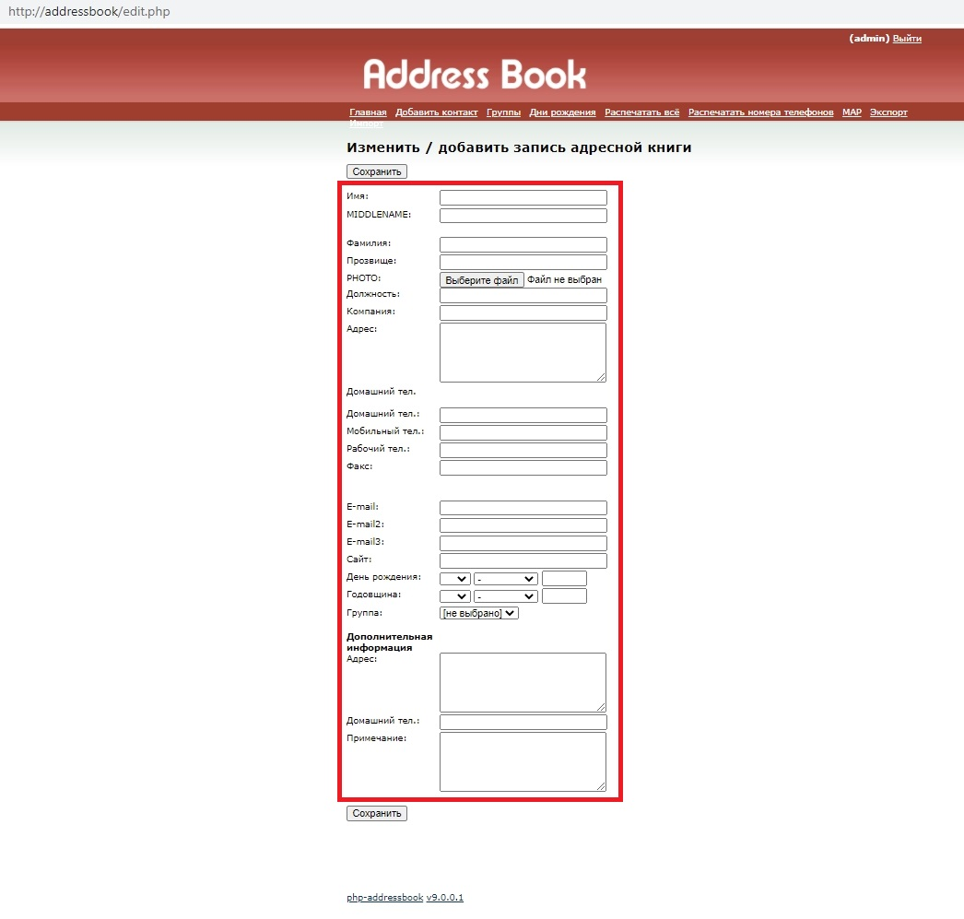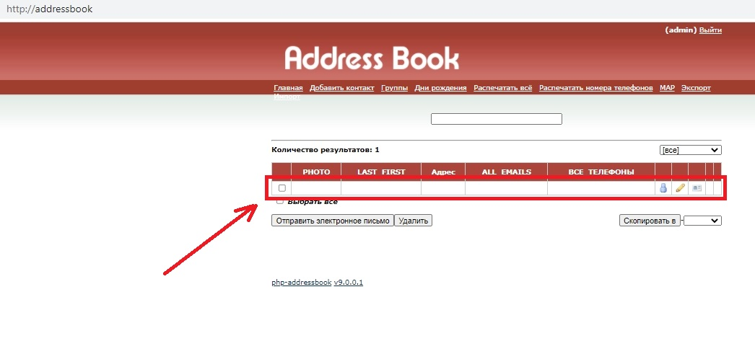

**B-2. The fields “Firstname”, “Middlename”, “Lastname” accepts numbers**

**Priority: High**

**Steps to reproduce:**

1. Open <http://addressbook/>  
2. Log in with valid credentials  
3. Click "Add contact"  
4. Click on the button [NEXT]  
5. Fill the fields “Firstname”, “Middlename”, “Lastname” with numbers  
6. Click on the button [Save]

**Actual result**: The form is saved with invalid data in the field “Firstname”, “Middlename”, “Lastname”

**Expected result**: The fields “Firstname”, “Middlename”, “Lastname” is highlighted in red. Error message "The fields accepts letters only". The button [Save] is inactive

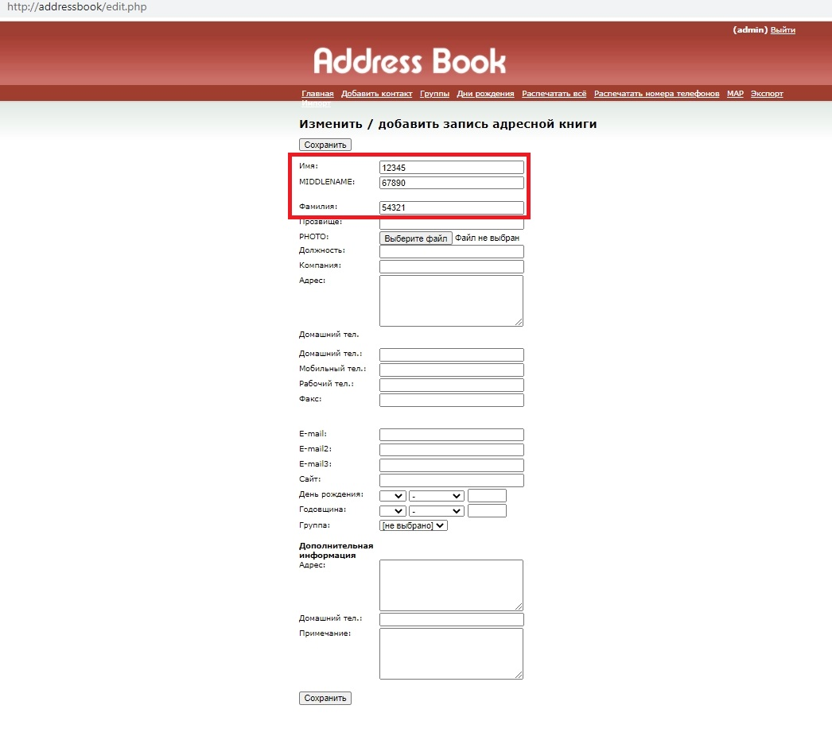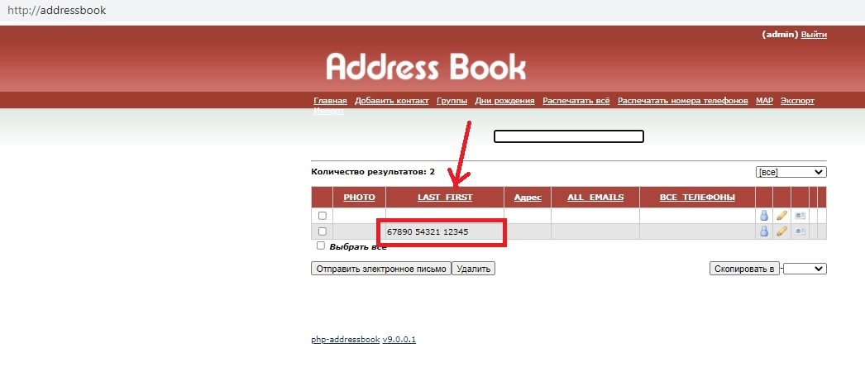

**B-3. Invalid auto-fill of the field "E-mail"**

**Priority: High**

**Steps to reproduce:**

1. Open <http://addressbook/>  
2. Log in with valid credentials  
3. Click "Add contact"  
4. Click on the button [NEXT]  
5. Fill the fields "Firstname", "Middlename" and "Lastname" with valid data

**Actual result:** Invalid auto-fill of the field "E-mail"

**Expected result**: The field "E-mail" stay empty

